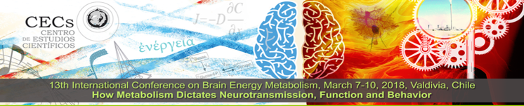
REGISTRATION & ROOM
RESERVATION
13th International Conference on
Brain Energy Metabolism
March 7-10, 2018

Av. Arturo Prat 514, Valdivia, 5110466, Phone: (56) 63-2234503 Fax: (56) 63-2234517 www. http://cecs.cl/icbem/
HOW TO REGISTER
Please email this form to Ms. Loreto Fernandez at ICBEM@cecs.cl
_________________________________________________________________________
Note that because of conference size limitations, registrations will be received on a FIRST-COME FIRST-SERVED basis
until registration of 105 participants or until Friday November 3rd 2017. _________________________________________________________________________

PERSONAL DETAILS Please print clearly.

Last Name ___________________________ First Name _________________________________ Dr. Mr. Ms.
University or work affiliation_______________________________________________________________________________
Address _________________________________________________________________________________________________
City __________________________________ State ___________ Zip ______________________ Country______________
E-mail address__________________________________________Phone number____________________________________
Name of guest___ ______________________________________________________________________________________

REGISTRATION FEE The meeting registration fee is US$ 880 for participants, US$280 for guests over age 14, and US$ 620 for students. All costs are per person and include conference registration, 4 nights hotel accommodation, opening reception, most meals, an excursion to a temperate forest reserve, boat trip and farewell dinner. Guest have access to all activities except scientific sessions.
Registration Fees
Meeting Participant US$ 880 $____________
Adult Guest US$ 280 $____________
Student US$ 620 $____________
Total $____________

Special requests: Vegetarian Gluten-Free Child care other (please specify)

_______________________________________________________________________________________________________________________________
Please return this completed form labelled with your name (e.g. SmithMary.pdf) to Ms. Loreto Fernandez at ICBEM@cecs.cl Instructions will then be emailed to you for payment through a secure commercial credit card server or, alternatively, through wire transfer.
_____________________________________________________________________________________________

